

PRODUCTION PRACTICE

ACTIVITY:

STUDENT PRACTICES

2024-2025

My path



Table of Contents

Introduction 3

Key features include: 3

Diagrams 4

Database ER diagram 4

Sprint checks 5

User stories 7

For students 7

For teachers 8

Integration Between the AI Module and the Web Application 8

GitHub Projects 9

Our project 10

Conclusion 11

# Introduction

This project aims to develop a web application using **Flask** and **Python** that predicts a student's academic success through a machine learning model. The platform combines data collection, predictive analytics, and educational resources to support students in their learning journey.

## Key features include:

* A survey form to collect student data and build a training dataset.
* A prediction tool for estimating student performance using ML algorithms such as linear regression, logistic regression, perceptron, or neural networks.
* A video lesson portal with subject-specific content managed by teachers.
* Recommendation system that suggests relevant videos when a student is at risk of underperforming.



# Diagrams

## Database ER diagram

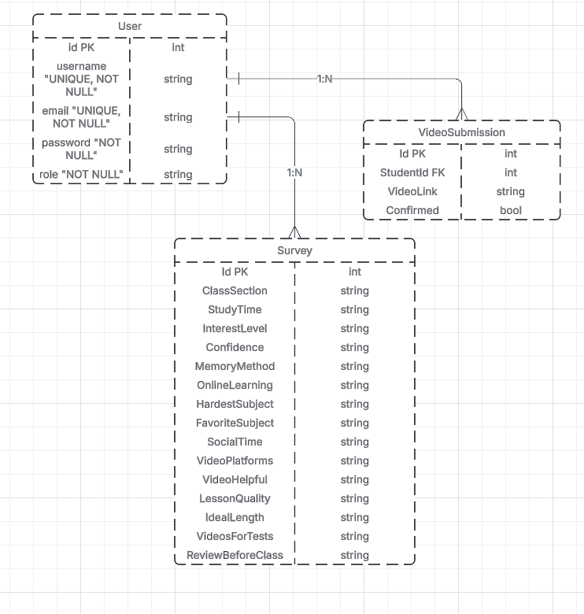

# Sprint checks

|  |  |  |  |
| --- | --- | --- | --- |
| Sprint | Week | Task completed | Made by |
| Sprint 1 | First Week | ✅ Create the login page  ✅ Create the register page  ✅ Create the design of the login page  ✅ Create the design for the register page  ✅ Create the project survey  ✅ Create base.html | - Viktoria  - Viktoria  - Demetra  - Demetra  - Dimitar |
| Sprint 2 | Second Week | ✅ Create dashboard  ✅ Change the username  ✅ Making a survey  ✅ Create a database for the survey  ✅ Change the password  ✅ Create the tips page  ✅ Create README file  ✅ Create video page ✅ Create the logo of the project | - Alexandra  - Alexandra  - Viktoria  -Viktoria  - Alexandra  - Viktoria  - Steliyan  - Alexandra  - Demetra |
| Sprint 3 | Third Week | ✅ Create requirements file  ✅ Create classes page  ✅ Create the email feature  ✅ Create a teacher page  ✅ Create teacher dashboard  ✅ Create “My posts” page  ✅ Add posts to your profile | - Viktoria  - Viktoria  - Alexandra  - Demetra  - Demetra  - Viktoria  - Viktoria |
| Sprint 4 | Fourth Week | ✅Create unit tests for the project  ✅Create database ER diagram  ✅Add comments to the code  ✅Create AI model  ✅Create personal pages for the errors  ✅Create user stories for the project  ✅Create migrations folder | - Dimitar and Demetra  - Steliyan  - Viktoria and Alexandra  - Alexandra and Dimitar    - Alexandra  - Steliyan  - Alexandra |
| Sprint 5 | Fifth Week | ✅Create dataset for ai  ✅Create show password option  ✅Add motivational videos to student dashboard  ✅Improve the welcome page  ✅Create teacher dashboard design  ✅Create send motivation video page | - Alexandra  - Alexandra  - Alexandra  - Alexandra  - Dimitar  - Demetra |
| Sprint 6 | Sixth Week | ✅Create admin profile  ✅Create admin dashboard  ✅Create footer  ✅Add remove videos option in admin profile  ✅Create admin design | - Alexandra  - Alexandra  - Alexandra  - Alexandra  - Demetra |

# User stories

## For students

|  |
| --- |
| 1. **As a student**, I want to upload a video link, so that I can receive confirmation from the teacher. |
| 1. **As a student**, I want to see a list of my previously uploaded videos, so that I can track which ones have been confirmed. |
| 1. **As a student**, I want to fill out a survey about my learning experience, so that I can see the right videos for me. |
| 1. **As a student**, I want to search for other users, so that I can connect and share content with them. |
| 1. **As a student**, I want to see my username in the top right corner, so that I know I’m logged into the system. |
| 1. **As a student**, I want to switch between light and dark mode, so that I can work comfortably depending on the lighting. |
| 1. **As a student**, I want to quickly navigate to different sections (Survey, Dashboard, Videos, Friends & Classes), so that I can move through the platform easily. |
| 1. **As a student**, I want to enter a YouTube link into a designated field, so that I can avoid mistakes when uploading videos. |
| 1. **As a student**, I want to check motivational messages or tips, so that I feel encouraged to keep learning. 2. **As a student,** I want to create my own posts, that my friends can see. 3. **As a student**, I want to change my password, email or username |
|  |

## For teachers

1) **As a teacher,** I want to approve the videos that the student has sent.

2) **As a teacher,** I want to see a list of all the students who have registered.

3) **As a teacher,** I want to be able to register students.

4) **As a teacher**, I want to be able to remove students from the course.

5) **As a teacher**, I want to change my password, email or username whenever I want.

# Integration Between the AI Module and the Web Application

The integration between **the AI module** and the **web application** enables real-time personalized video recommendations tailored to individual user preferences. After **a user completes the survey** on the web interface, their responses are sent to **the AI module**, where a logistic regression model is used to evaluate how well each video matches the user's learning preferences. This model assigns a probability score to **each video**, reflecting the likelihood that it will be useful and engaging for the user. The top-scoring videos are returned to the **web application** and displayed in a ranked list with matching scores and justifications.

# GitHub Projects

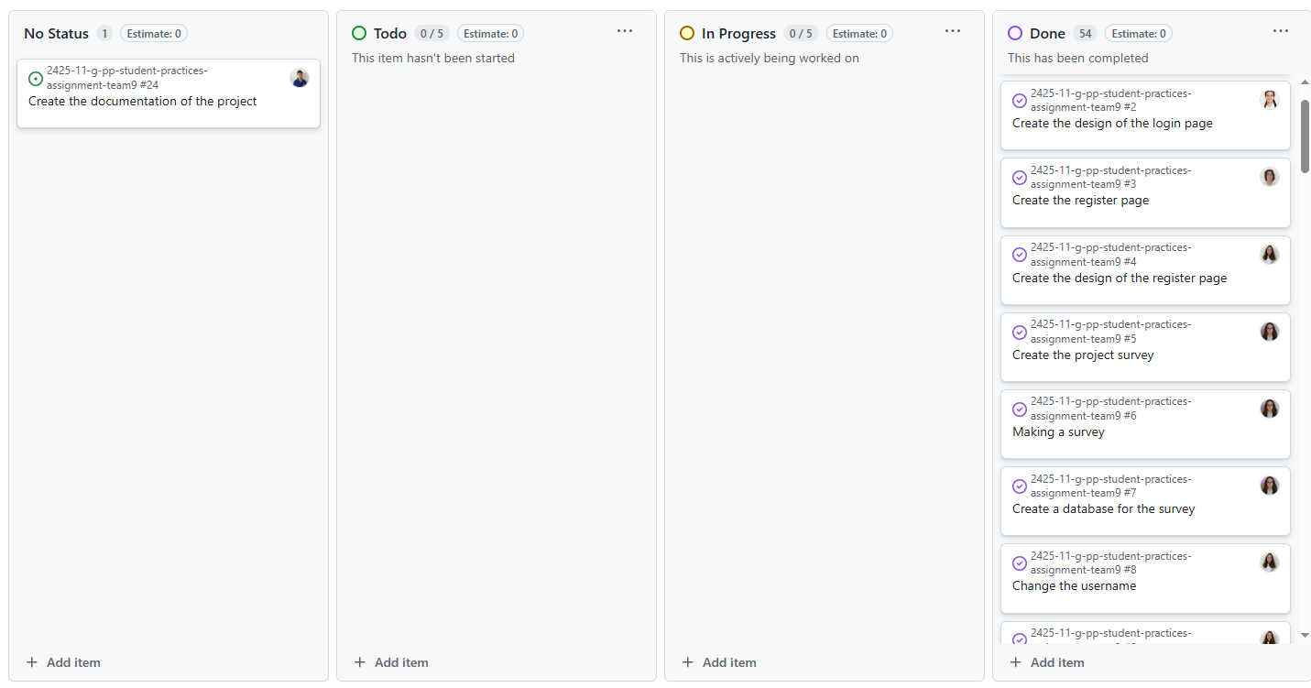

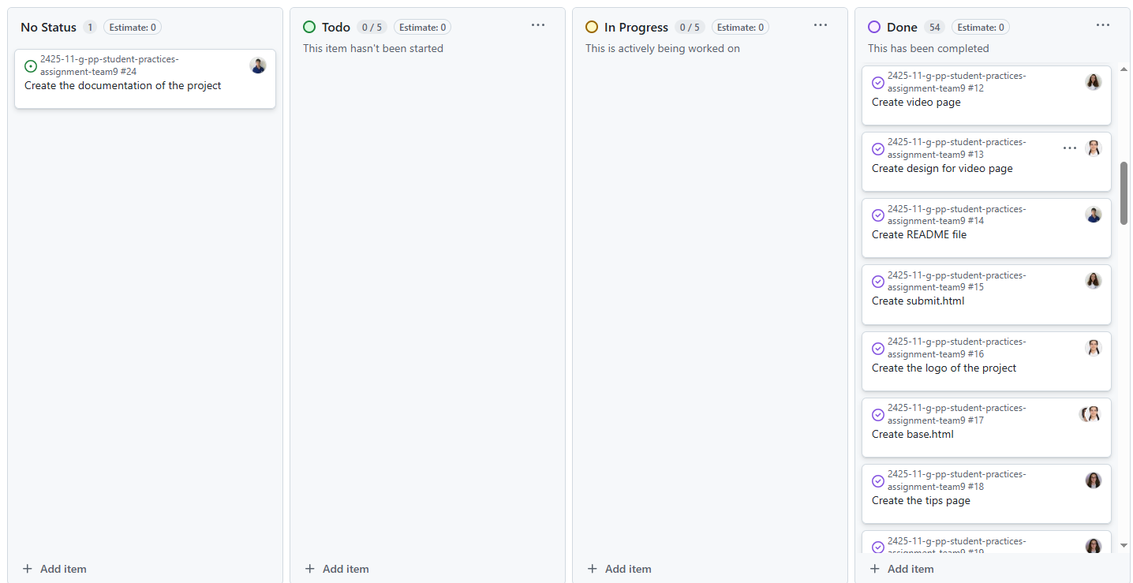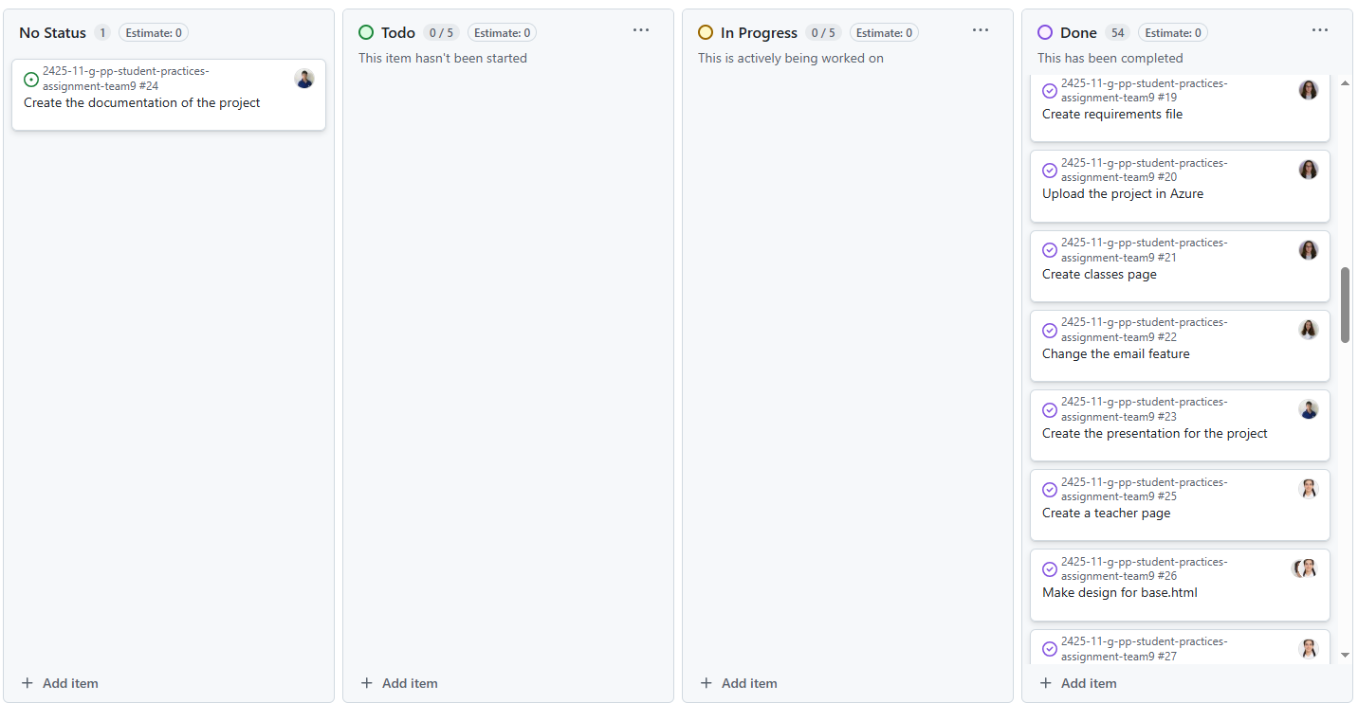

# Our project

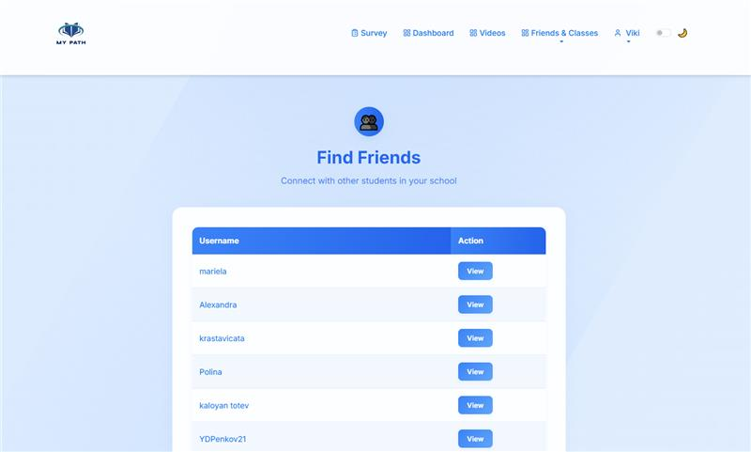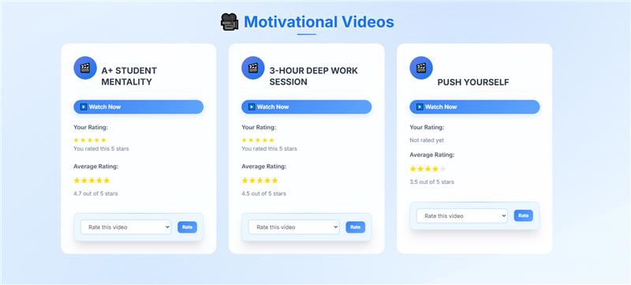

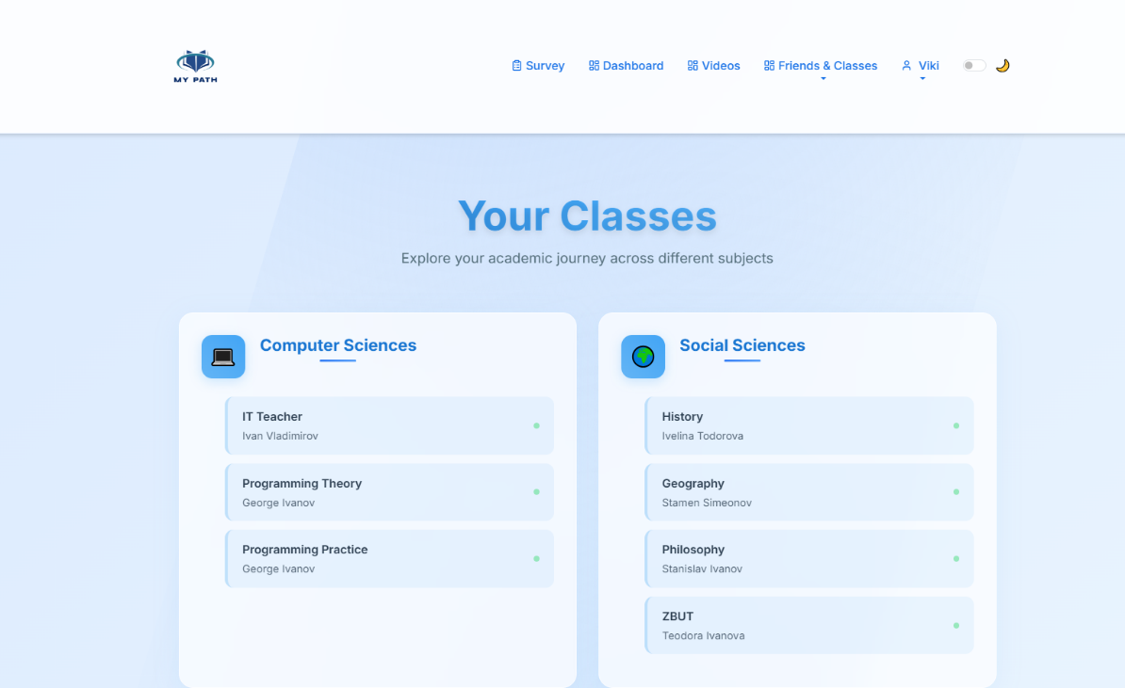

# Conclusion

With this project, our team successfully developed a web application using **Flask** and **Python**, with the main goal of **predicting a student’s academic success** through a machine learning (ML) model. By creating a carefully designed questionnaire, we collected high-quality data to build a dataset, which was then used to train an ML model using logistic regression.

The platform features an **interactive prediction interface**, accessible to registered users, allowing them to receive personalized recommendations based on their input data. The website also includes a video portal covering all school subjects, giving teachers the ability to **upload and manage educational video content**, while students can **suggest additional resources** (e.g., YouTube videos) that teachers can approve for display on the platform.

This project combines technology, functionality, and educational value to create an **effective and accessible tool for improving student performance**, while also promoting the digitalization of the learning process and encouraging a more individualized approach to education.

